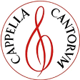
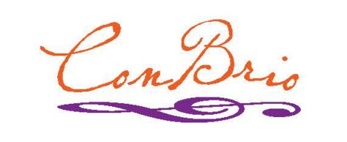
SummerSings
Series 2016
The SummerSings Series offers informal single-evening opportunities to sing great choral music
with Connecticut choral conductors and featured soloists. SummerSings is co-sponsored by
Cappella Cantorum and the Con Brio Choral Society,
Informal! Open to all, no advance registration.
Just come and enjoy singing!
Monday evenings
Registration 7pm ∙ Sing from 7:30 – 9:30pm
$8 fee includes a score to borrow for the evening,
but please bring your own masterwork score if you have one.
———————————— SCHEDULE —————————————————
June 13 Mozart Requiem Mass in D Minor Barry Asch – Cappella Cantorum
June 20 Paukenmesse Franz Joseph Haydn Sarah Kaufold – The Shoreline Chorale
June 27 Requiem John Rutter Kristine Pekar – Lyme-Old Lyme H/S
————————————— MID-SEASON BREAK ————————–————————
Aug 1 Gloria Antonio Vivaldi Drew Collins – Central CT State Univ
Aug 8 Elijah (selections),Psalm 42 Felix Mendelssohn Mark Singleton – Voce, ECSC
Aug 15 Mass in C L. van Beethoven Steve Bruce – Con Brio Choral Society
———–——–—————–————————–——————————–——————–————
All SummerSings sessions are held at
St. Paul Evangelical Lutheran Church
56 Great Hammock Road, Old Saybrook, CT
For more information and details,
visit cappellacantorum.org or conbrio.org
phone (860) 767-9409 or (203) 245-6947
5/19/2016f

