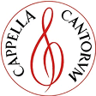
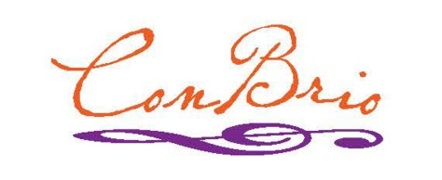
SummerSings
Series 2017
The SummerSings Series offers informal single-evening opportunities to sing great choral music
with Connecticut choral conductors and featured soloists. SummerSings is co-sponsored by
Cappella Cantorum and the Con Brio Choral Society.
Informal! Open to all, no advance registration.
Just come and enjoy singing!
Monday evenings
Registration 7pm ∙ Sing from 7:30 – 9:30pm
$10 fee ( $5 students) includes a score to borrow for the evening,
but please bring your own score if you have one.
——————————————— SCHEDULE ———————————————————
June 12 Requiem Mass W. A. Mozart Rachael Allen – Westbrook High School
in D Minor K. 626
June 19 Lord Nelson Mass Joseph Haydn Barry Asch – Cappella Cantorum
Missa in Angustiis Hob XXII:11
June 26 Bill of Rights Neely Bruce Neely Bruce – Wesleyan University
Motet in the Revolutionary style of William Billings
————————————— MID-SEASON BREAK ————————–————————
July 31 Requiem Gabriel Faure Jeremy Milton – Old Saybrook High School
D minor, Op. 48
Aug 7 Gloria RV589 Antonio Vivaldi Kevin Buno – Guilford High School
Te Deum C Major Joseph Haydn
Aug 14 Requiem Johannes Brahms Steve Bruce – Con Brio Choral Society
Op. 45 German: Ein deutsches Requiem
———–——–—————–————————–——————————–——————–————
St. Paul Evangelical Lutheran Church
56 Great Hammock Road, Old Saybrook, CT
For more information and details,
visit cappellacantorum.org or conbrio.org
or phone (860) 767-9409 or (203) 530-0002
5/6/2017

